**Color usage and palettes**link

The Material Design color system helps you apply color to your UI in a meaningful way. In this system, you select a primary and a secondary color to represent your brand. Dark and light variants of each color can then be applied to your UI in different ways.

**Colors and theming**

Color themes are designed to be harmonious, ensure accessible text, and distinguish UI elements and surfaces from one another.

The [Material Design palette tool](https://m2.material.io/design/color/the-color-system#tools-for-picking-colors) or 2014 Material Design palettes are available to help you select colors.

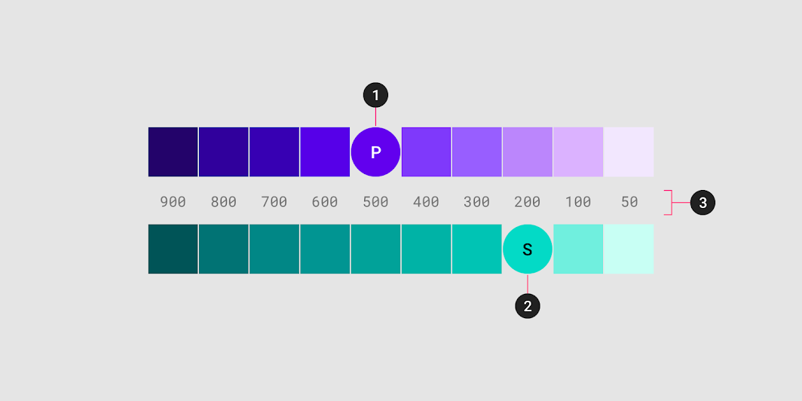

A sample primary and secondary palette  
  
1. Primary color  
2. Secondary color  
3. Light and dark variants

**Principles**

Color indicates which elements are interactive, how they relate to other elements, and their level of prominence. Important elements should stand out the most. Text...



**Hierarchical**

Color indicates which elements are interactive, how they relate to other elements, and their level of prominence. Important elements should stand out the most.

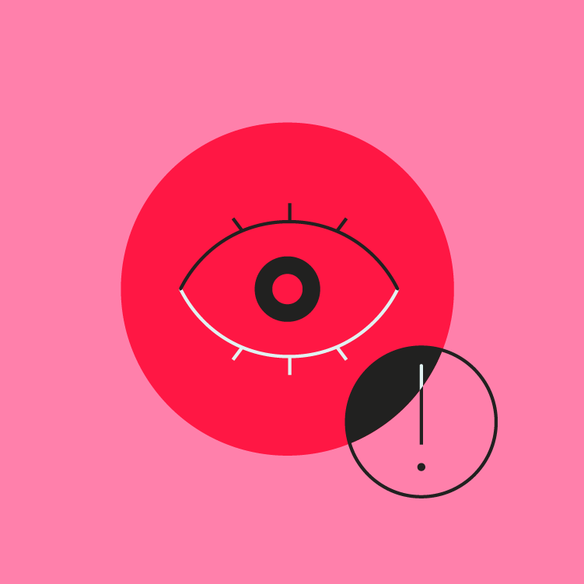

**Legible**

Text and important elements, like icons, should meet legibility standards when appearing on colored backgrounds.

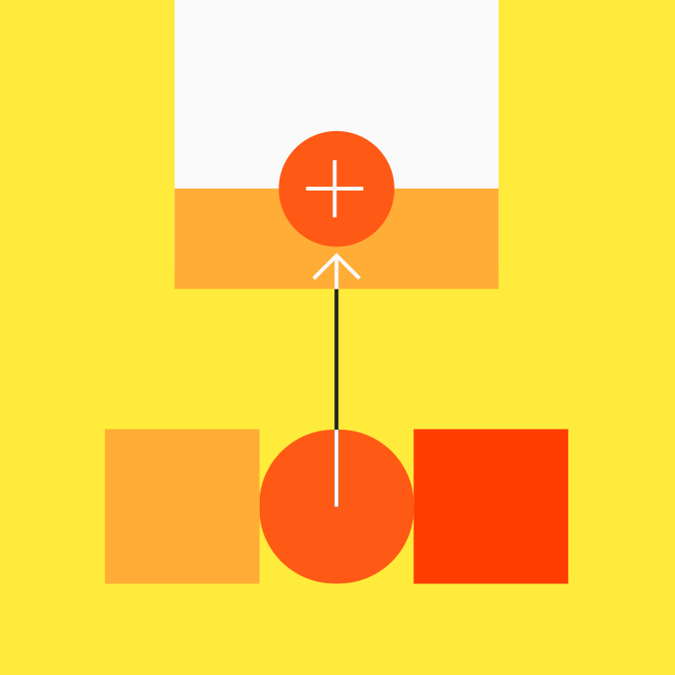

**Expressive**

Show brand colors at memorable moments that reinforce your brand’s style.

**Color theme creation**link

**The baseline Material color theme**

Material Design comes designed with a built-in, baseline theme that can be used as-is, straight out of the proverbial box. It includes default colors for:...

Material Design comes designed with a built-in, baseline theme that can be used as-is, straight out of the proverbial box.

This includes default colors for:

* Primary and secondary colors
* Variants of primary and secondary colors
* Additional UI colors, such as colors for backgrounds, surfaces, errors, typography, and iconography.

All of these colors can be customized for your app.

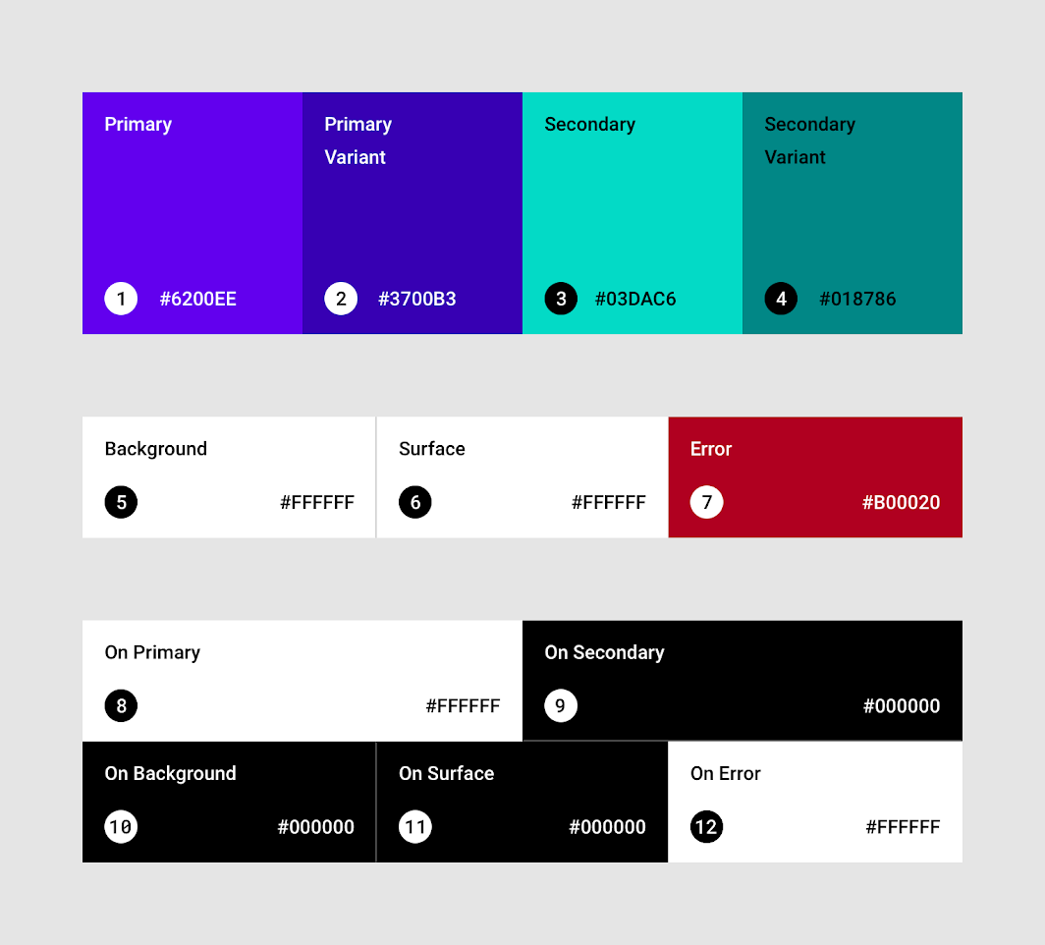

The baseline Material color theme

**Primary color**

A primary color is the color displayed most frequently across your app’s screens and components. Your primary color can be used to make a color...

A **primary color** is the color displayed most frequently across your app's screens and components.

**Dark and light primary variants**

Your primary color can be used to make a color theme for your app, including dark and light primary color variants.

**Distinguish UI elements**

To create contrast between UI elements, such as a top app bar from a system bar, you can use light or dark variants of your primary colors. You can also use these to distinguish elements within a component, such as the icon of a floating action button from its circular container.

volume\_off

A top app bar uses light and dark primary color variants to distinguish it from a system bar.

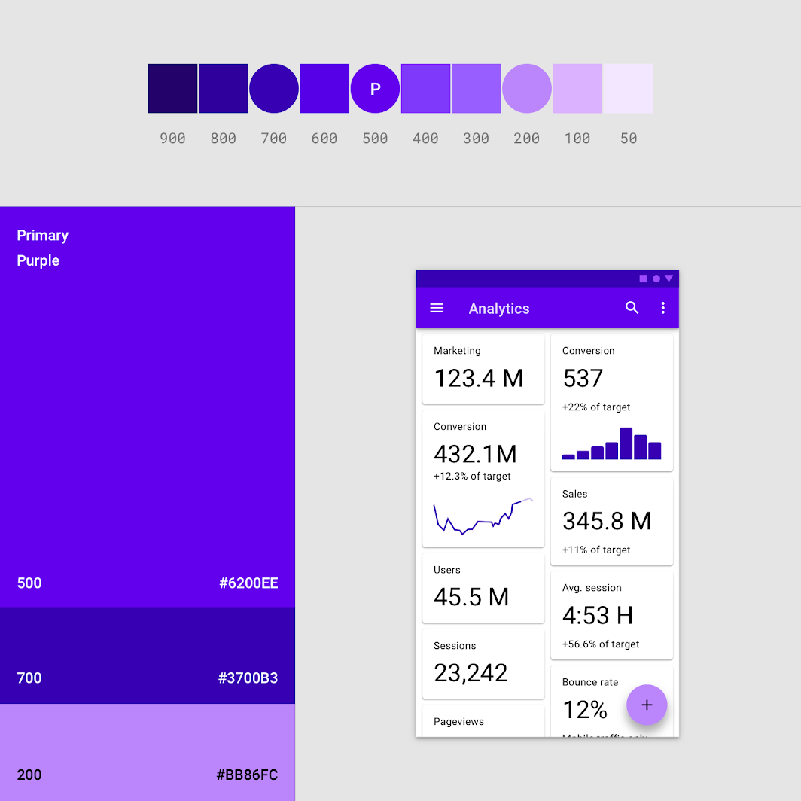

This UI uses a primary color and two primary variants.

**Secondary color**

A secondary color provides more ways to accent and distinguish your product. Having a secondary color is optional, and should be applied sparingly to accent...

A **secondary color** provides more ways to accent and distinguish your product. Having a secondary color is optional, and should be applied sparingly to accent select parts of your UI.

If you don’t have a secondary color, your primary color can also be used to accent elements.

Secondary colors are best for:

* Floating action buttons
* Selection controls, like sliders and switches
* Highlighting selected text
* Progress bars
* Links and headlines

**Dark and light secondary variants**

Just like the primary color, your secondary color can have dark and light variants. A color theme can use your primary color, secondary color, and dark and light variants of each color.

volume\_off

Dark and light variants of primary and secondary colors

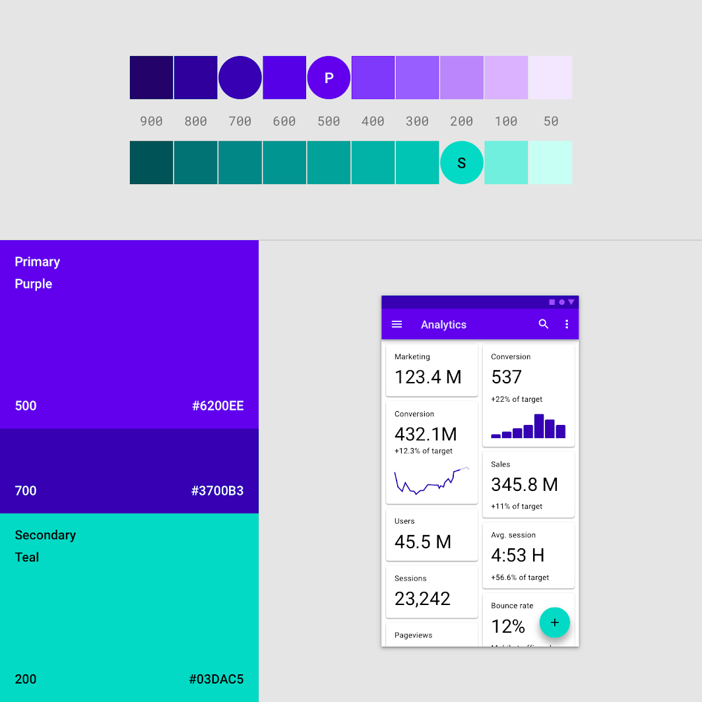

This UI uses a color theme with a primary color, a primary variant, and a secondary color.

**Surface, background, and error colors**

Surface, background, and error colors typically don’t represent brand:

Surface, background, and error colors typically don’t represent brand:

* **Surface colors** affect surfaces of components, such as cards, sheets, and menus.
* The **background color** appears behind scrollable content. The baseline background and surface color is #FFFFFF.
* **Error color** indicates errors in components, such as invalid text in a text field. The baseline error color is #B00020.

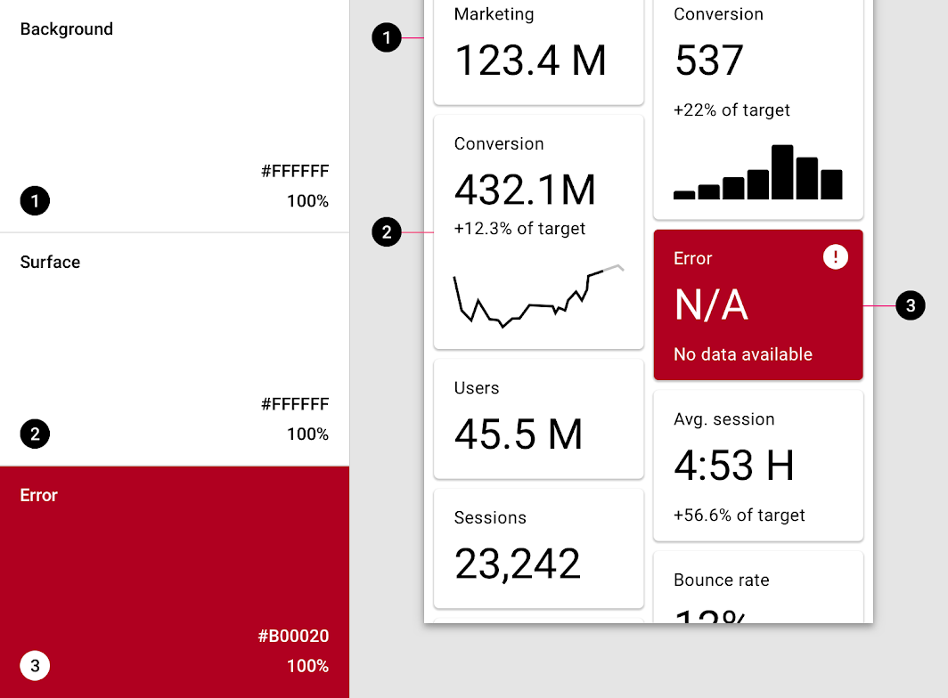

A UI showcasing the baseline colors for background, surface, and error color:  
  
1. Baseline background color: #FFFFFF  
2. Baseline surface color: #FFFFFF  
3. Baseline error color: #B00020

**Typography and iconography colors**

App surfaces use colors from specific categories in your color palette, such as a primary color. Whenever elements, such as text or icons, appear in...

**"On" colors**

App surfaces use colors from specific categories in your color palette, such as a primary color. Whenever elements, such as text or icons, appear in front of those surfaces, those elements should use colors designed to be clear and legible against the colors behind them.

This category of colors is called “on” colors, referring to the fact that they color elements that appear “on” top of surfaces that use the following colors: a primary color, secondary color, surface color, background color, or error color. When a color appears “on” top of a primary color, it’s called an “on primary color.” They are labelled using the original color category (such as primary color) with the prefix “on.”

“On” colors are primarily applied to text, iconography, and strokes. Sometimes, they are applied to surfaces.

The default values for “on” colors are #FFFFFF and #000000.

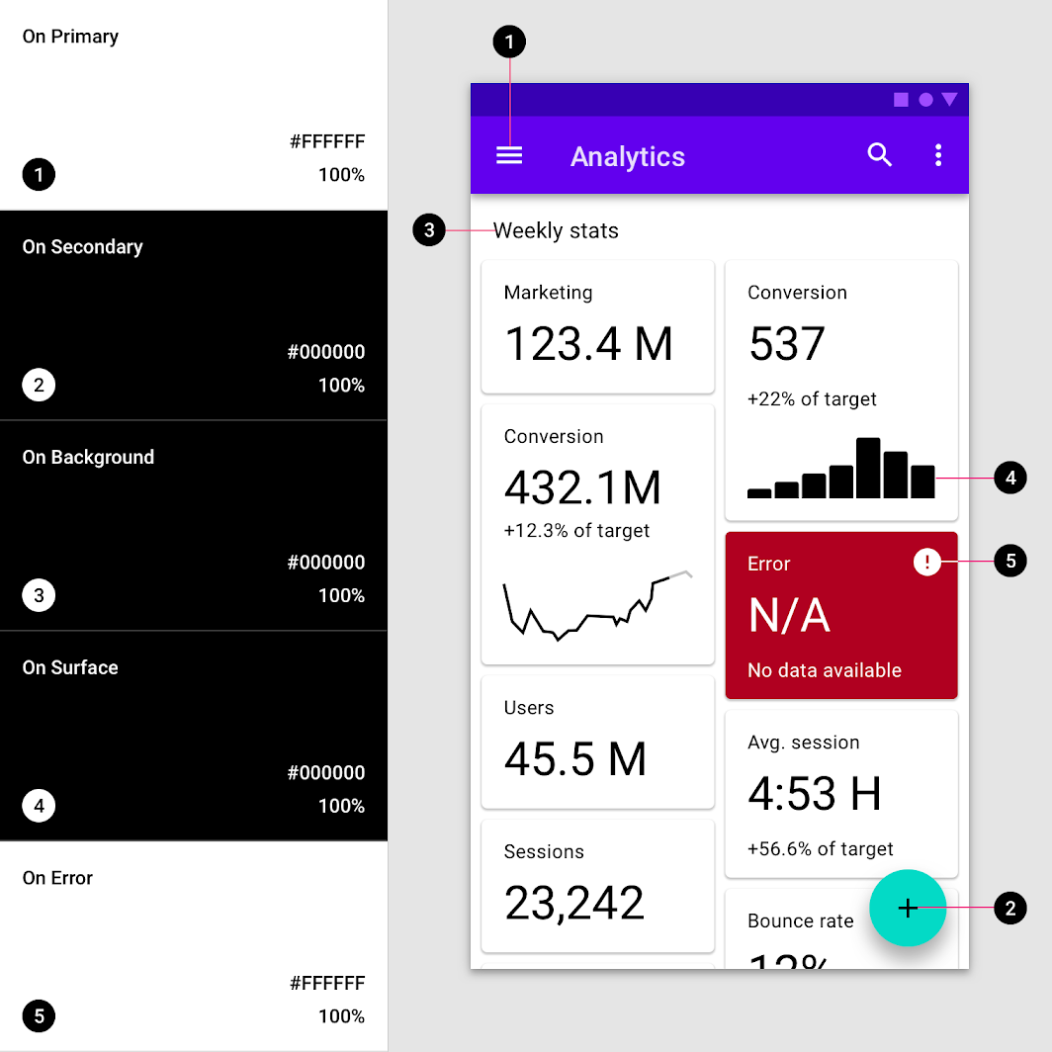

A UI showcases the baseline colors for text and iconography:  
  
1. Baseline on primary color #FFFFFF  
2. Baseline on secondary color #FFFFFF  
3. Baseline on background color #B00020  
4. Baseline on surface color #B00020  
5. Baseline on error color #B00020

**Accessible colors**

To ensure an accessible background behind light or dark text, your background can use light or dark variants of your primary and secondary colors. Alternatively,...

To ensure an accessible background behind light or dark text, your background can use light or dark variants of your primary and secondary colors.

Alternatively, these colors can be used for typography that appears in front of light and dark backgrounds.

**Color swatches**

A **swatch** is a sample of a color chosen from a range of similar colors.

volume\_up

Check marks indicate whether a text color is legible in front of a background:  
  
• A **white check mark** indicates when white text is legible on a background color  
• A **black check mark** indicates when black text is legible on a background color

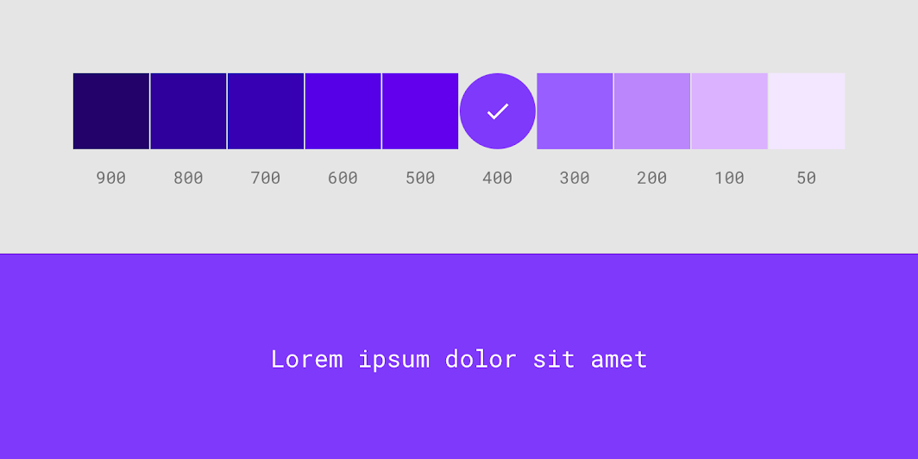

Apps that use white text must have backgrounds that are accessible against white text. These white check marks indicate when white text is accessible against various background color swatches. The 400 color swatch is applied to this UI.

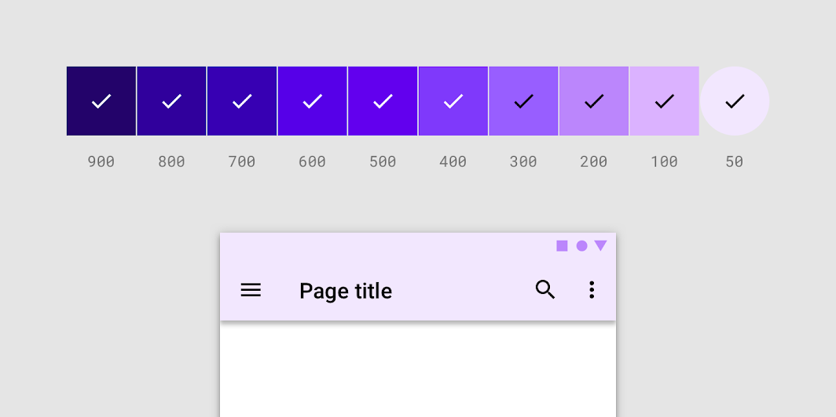

Apps that use black text must have backgrounds that are accessible against black. These black check marks indicate when black text is accessible against various background color swatches. The 50 color swatch is applied to this UI.

**Alternative colors**

The Material Design color system supports alternative colors, which are colors used as alternatives to your brand’s primary and secondary colors (they constitute additional colors...

The Material Design color system supports **alternative colors**, which are colors used as alternatives to your brand’s primary and secondary colors (they constitute additional colors to your theme). Alternative colors can be used to distinguish different sections of a UI.

Alternative colors are best for:

* Apps with light and dark themes
* Apps with different themes in different sections
* Apps that are part of a suite of products

Alternative colors should be used cautiously, because they can be challenging to implement cohesively with existing color themes.

**Light and dark themes**

Some apps have both light and dark themes. To maintain visibility of elements and legibility of text, you can adapt the different color schemes for dark and light themes.

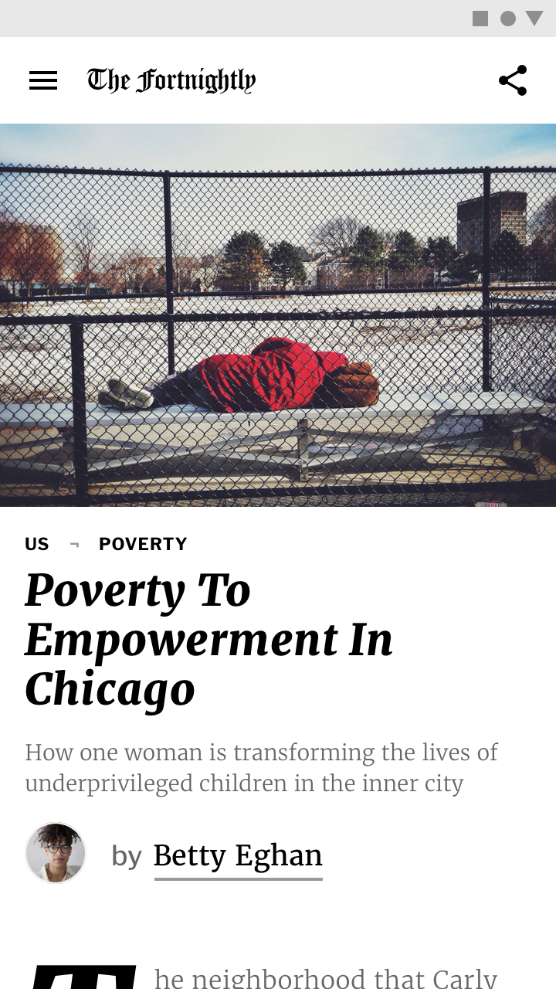

A news app in a light theme uses a primary and secondary scheme.

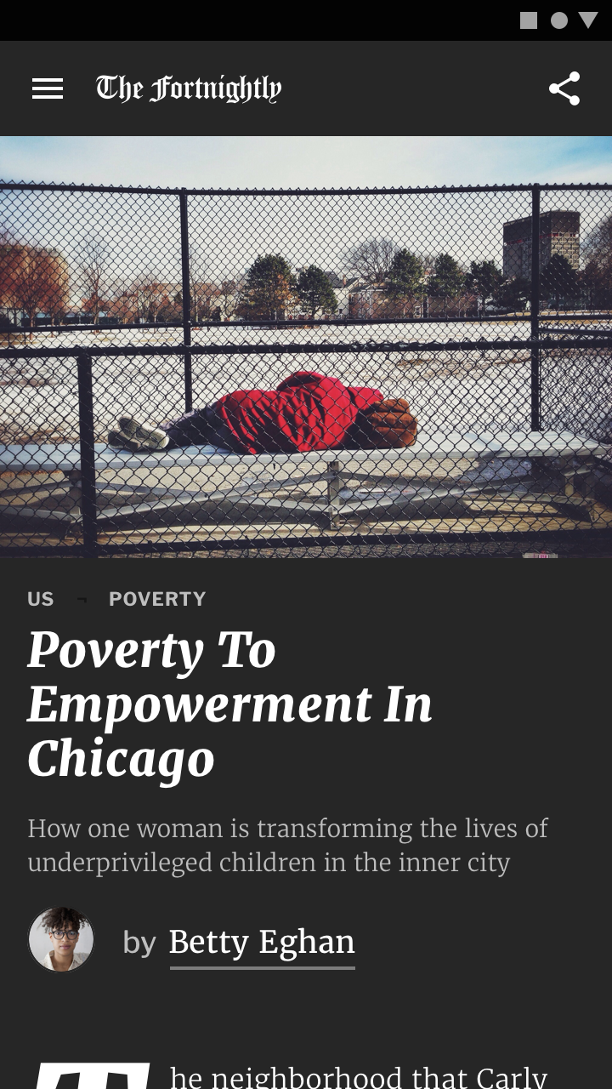

The same news app in dark theme uses a different color scheme to maintain legibility.

**Alternative colors for section themes**

Alternative colors can be used to theme different parts of an app. Owl is an educational app that provides courses for people who want to...

Alternative colors can be used to theme different parts of an app.

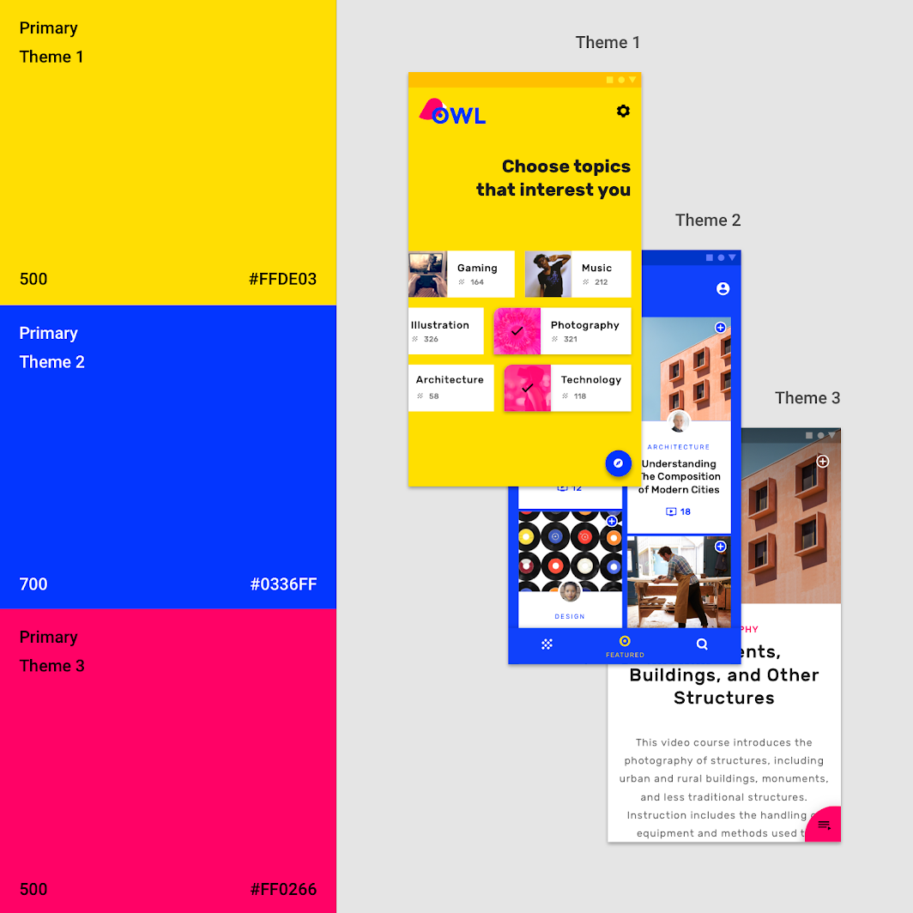

This app has three primary colors. Distinct themes are used in different parts of the app, allowing users to better locate themselves within it.

**Theme 1**

Yellow is used as the primary color for areas such as onboarding and choosing content of interest.

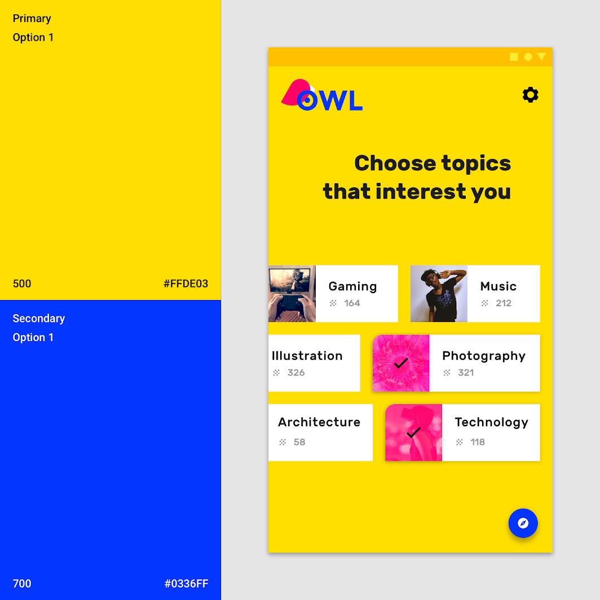

**Theme 2**

Blue is used as the primary color for areas of the app that relate to the user’s personal account, such as selected courses.

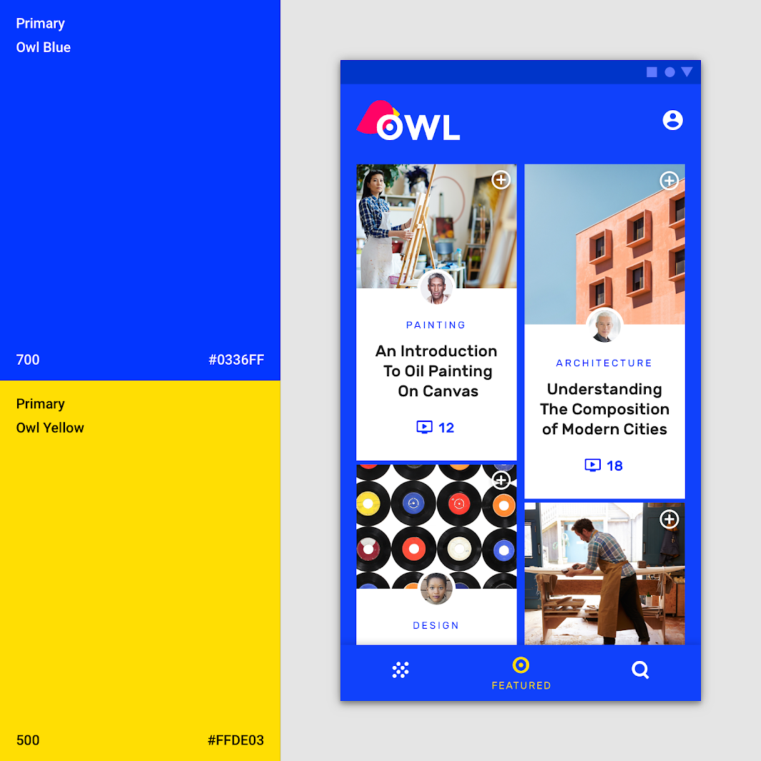

**Theme 3**

Pink is used as the primary color for courses.

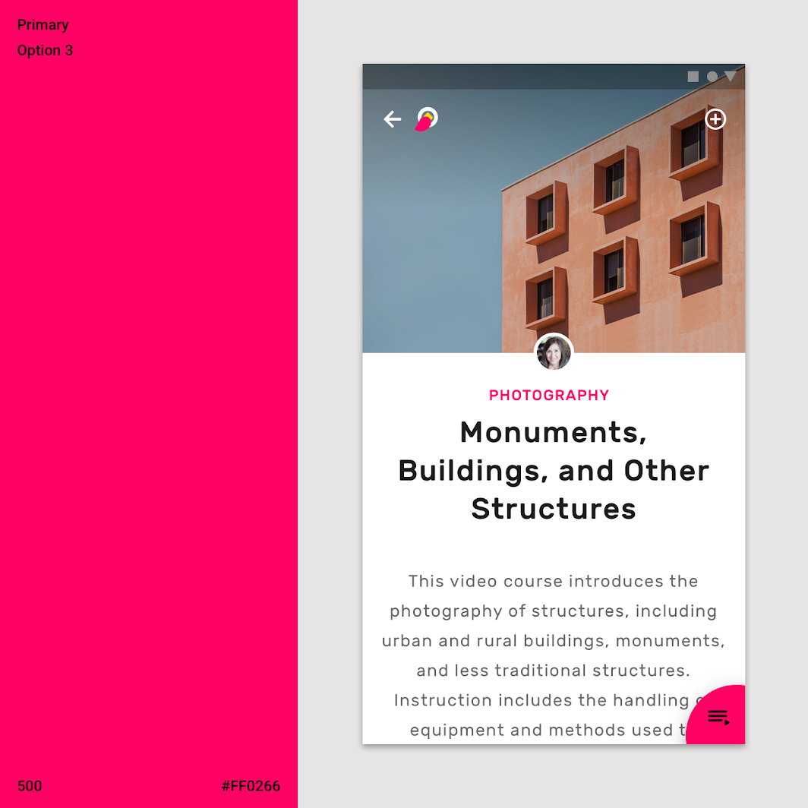

[Owl](https://m2.material.io/design/material-studies/owl.html" \o "Owl" \t "_self)

[Owl is an educational app that provides courses for people who want to explore and learn new skills.](https://m2.material.io/design/material-studies/owl.html" \o "Owl" \t "_self)

[Related articlearrow\_downward](https://m2.material.io/design/material-studies/owl.html" \o "Owl" \t "_self)

**Additional colors for data visualization**

Apps can use additional colors to convey categories that are outside of your main color theme. They are still a part of your full color...

Apps can use additional colors to convey categories that are outside of your main color theme. They are still a part of your full color palette.

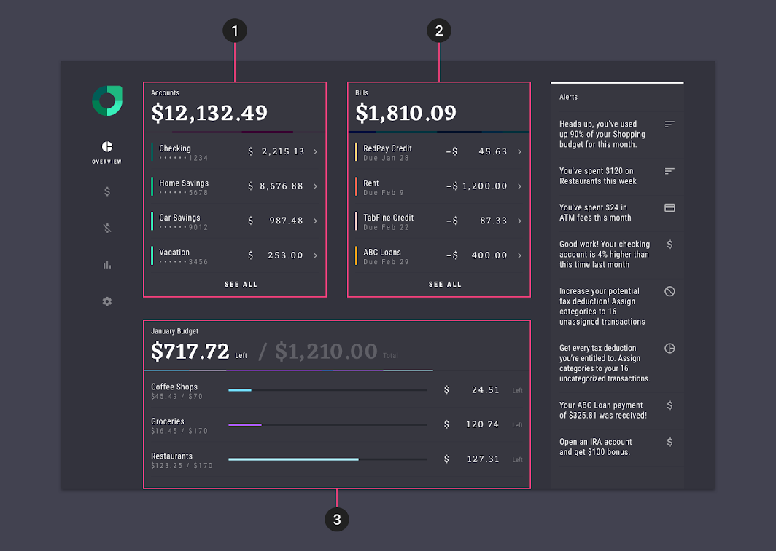

This app has a color theme with five additional colors, which it uses when multiple data visualizations are shown on the same page.  
  
1. The Accounts section uses green  
2. The Bills section uses orange and yellow  
3. The Budget section uses purple and blue  
  
(Scaled down to 50%)

[Rally](https://m2.material.io/design/material-studies/rally.html" \o "Rally" \t "_self)

[Rally is a personal finance app that demonstrates how Material Design can be used for finance.](https://m2.material.io/design/material-studies/rally.html" \o "Rally" \t "_self)

[Related articlearrow\_downward](https://m2.material.io/design/material-studies/rally.html" \o "Rally" \t "_self)

**Tools for picking colors**link

**Material palette generator**

The Material palette generator can be used to generate a palette for any color you input. Hue, chroma, and lightness are adjusted by an algorithm...

The Material palette generator can be used to generate a palette for any color you input. Hue, chroma, and lightness are adjusted by an algorithm that creates palettes that are usable and aesthetically pleasing.

**Input colors**

Color palettes can be generated based on the primary input color, and whether the desired palette should be analogous, complementary, or triadic in relation to the primary color.

Alternatively, the tool can generate expanded palettes, based on any primary and secondary color.

**Color variations for accessibility**

These palettes provide additional ways to use your primary and secondary colors. They include lighter and darker options to separate surfaces and provide colors that meet accessibility standards.

**2014 Material Design color palettes**

These color palettes, originally created by Material Design in 2014, are comprised of colors designed to work together harmoniously, and can be used to develop

These color palettes, originally created by Material Design in 2014, are comprised of colors designed to work together harmoniously, and can be used to develop your brand palette. To generate your own harmonious palettes, use the palette generation tool.

Red 50#FFEBEE

100#FFCDD2

200#EF9A9A

300#E57373

400#EF5350

500#F44336

600#E53935

700#D32F2F

800#C62828

900#B71C1C

A100#FF8A80

A200#FF5252

A400#FF1744

A700#D50000

Pink 50#FCE4EC

100#F8BBD0

200#F48FB1

300#F06292

400#EC407A

500#E91E63

600#D81B60

700#C2185B

800#AD1457

900#880E4F

A100#FF80AB

A200#FF4081

A400#F50057

A700#C51162

Purple 50#F3E5F5

100#E1BEE7

200#CE93D8

300#BA68C8

400#AB47BC

500#9C27B0

600#8E24AA

700#7B1FA2

800#6A1B9A

900#4A148C

A100#EA80FC

A200#E040FB

A400#D500F9

A700#AA00FF

Deep Purple 50#EDE7F6

100#D1C4E9

200#B39DDB

300#9575CD

400#7E57C2

500#673AB7

600#5E35B1

700#512DA8

800#4527A0

900#311B92

A100#B388FF

A200#7C4DFF

A400#651FFF

A700#6200EA

Indigo 50#E8EAF6

100#C5CAE9

200#9FA8DA

300#7986CB

400#5C6BC0

500#3F51B5

600#3949AB

700#303F9F

800#283593

900#1A237E

A100#8C9EFF

A200#536DFE

A400#3D5AFE

A700#304FFE

Blue 50#E3F2FD

100#BBDEFB

200#90CAF9

300#64B5F6

400#42A5F5

500#2196F3

600#1E88E5

700#1976D2

800#1565C0

900#0D47A1

A100#82B1FF

A200#448AFF

A400#2979FF

A700#2962FF

Light Blue 50#E1F5FE

100#B3E5FC

200#81D4FA

300#4FC3F7

400#29B6F6

500#03A9F4

600#039BE5

700#0288D1

800#0277BD

900#01579B

A100#80D8FF

A200#40C4FF

A400#00B0FF

A700#0091EA

Cyan 50#E0F7FA

100#B2EBF2

200#80DEEA

300#4DD0E1

400#26C6DA

500#00BCD4

600#00ACC1

700#0097A7

800#00838F

900#006064

A100#84FFFF

A200#18FFFF

A400#00E5FF

A700#00B8D4

Teal 50#E0F2F1

100#B2DFDB

200#80CBC4

300#4DB6AC

400#26A69A

500#009688

600#00897B

700#00796B

800#00695C

900#004D40

A100#A7FFEB

A200#64FFDA

A400#1DE9B6

A700#00BFA5

Green 50#E8F5E9

100#C8E6C9

200#A5D6A7

300#81C784

400#66BB6A

500#4CAF50

600#43A047

700#388E3C

800#2E7D32

900#1B5E20

A100#B9F6CA

A200#69F0AE

A400#00E676

A700#00C853

Light Green 50#F1F8E9

100#DCEDC8

200#C5E1A5

300#AED581

400#9CCC65

500#8BC34A

600#7CB342

700#689F38

800#558B2F

900#33691E

A100#CCFF90

A200#B2FF59

A400#76FF03

A700#64DD17

Lime 50#F9FBE7

100#F0F4C3

200#E6EE9C

300#DCE775

400#D4E157

500#CDDC39

600#C0CA33

700#AFB42B

800#9E9D24

900#827717

A100#F4FF81

A200#EEFF41

A400#C6FF00

A700#AEEA00

Yellow 50#FFFDE7

100#FFF9C4

200#FFF59D

300#FFF176

400#FFEE58

500#FFEB3B

600#FDD835

700#FBC02D

800#F9A825

900#F57F17

A100#FFFF8D

A200#FFFF00

A400#FFEA00

A700#FFD600

Amber 50#FFF8E1

100#FFECB3

200#FFE082

300#FFD54F

400#FFCA28

500#FFC107

600#FFB300

700#FFA000

800#FF8F00

900#FF6F00

A100#FFE57F

A200#FFD740

A400#FFC400

A700#FFAB00

Orange 50#FFF3E0

100#FFE0B2

200#FFCC80

300#FFB74D

400#FFA726

500#FF9800

600#FB8C00

700#F57C00

800#EF6C00

900#E65100

A100#FFD180

A200#FFAB40

A400#FF9100

A700#FF6D00

Deep Orange 50#FBE9E7

100#FFCCBC

200#FFAB91

300#FF8A65

400#FF7043

500#FF5722

600#F4511E

700#E64A19

800#D84315

900#BF360C

A100#FF9E80

A200#FF6E40

A400#FF3D00

A700#DD2C00

Brown 50#EFEBE9

100#D7CCC8

200#BCAAA4

300#A1887F

400#8D6E63

500#795548

600#6D4C41

700#5D4037

800#4E342E

900#3E2723

Gray 50#FAFAFA

100#F5F5F5

200#EEEEEE

300#E0E0E0

400#BDBDBD

500#9E9E9E

600#757575

700#616161

800#424242

900#212121

Blue Gray 50#ECEFF1

100#CFD8DC

200#B0BEC5

300#90A4AE

400#78909C

500#607D8B

600#546E7A

700#455A64

800#37474F

900#263238

Black#000000

White#FFFFFF